**Below is the written test for Bongo’s Site Reliability Engineer position. Please read through the entire test before starting to write it.**

Q. Certain web pages are loading slowly in user’s browser for our live web application. What steps will you take to resolve the issue?

Answer:

1. If it is specific some pages which loading slow, we can check the access-log/error-log for this

Issue. There may be some coding or big image loading issue where we can talk with developer.

2. We can also check for server (CPU, Memory, Disk I/O, Network interface (MX/TX)) utilization and we can try to tune web application for better performance.

3. We can use web caching software like menarche, Varnish to serve web request more quickly.

Q. Imagine a scenario where a web application is serving from a single web server to the internet. What are the problems in this scenario? Design and architect a solution that will mitigate these problems? Or How would you design a scalable architecture with resiliency in mind for the following situations:

a. if a service is resource intensive b. a service needs to be low latency c. if parts of a service need to be restricted to certain geographical boundaries

Answer:

We should use high-availability load balancer with caching here:

1. Load balancer will distribute load equally in all servers.

2. Cache server will reduce your latency issue.

3. You can increase/decrease app server depend on User access load later.

4. We can user CDN server from Cloud (Amazon/google) to resolve geographical uses.

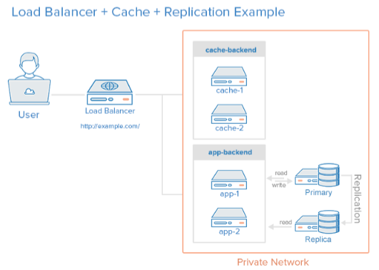

Q. Currently there’s no monitoring in place for the above single web server. How and what application will you use to monitor the resources/process in your new design?

Q. In our server we want to create a user who can only view logs using `less` from this path /var/log. Please explain how to achieve this.

Answer:

We may give acl/permission to the user for view the /var/log directory.

1st need to check the permission of /var/log. If the /var/log directory has no read or execute permission then, we may set acl

# setfacl –m u:username:r-- /var/log

Or, provide sudo on the /etc/sudoers file

user ALL=(ALL) NOPASSWD: /usr/bin/less /var/log/*

Login the user and create an alias in .bashrc file

cat .bashrc

alias less="sudo less"

[uuser@serevr ~]$ less /var/log

Q. Explain how you can ssh into a private server from the internet.

Answer: Step-01: We can run a proxy on Computer A that computer B would then connect to in order to access the internet through Computer A.

Something like this

+----------+ +-----------+

| |+----SSH+-->| |

| A | | B |

|+--------+| | |

Internet <-++-+PROXY<++<SSH Tunnel--+ |

|+--------+| | |

+----------+ +-----------+

Step-2: We can also configure a NAT IP Address against the private IP Address for login internet to private server.

Q. Write a bash function that will find all occurrences of an IPv4 from a given file.

Answer:

# cat ipadd-log.sh

#!/bin/bash

tcpdump -w /tmp/enp0s3-26082018.pcap -i enp0s3

Q. Share with us steps to run a web service container on 80 port.

root@docker1 test]# docker run -dit --name sohel-web -p 8080:80 -v /home/user/website/:/usr/local/apache2/htdocs/:Z httpd:2.4

Unable to find image 'httpd:2.4' locally

2.4: Pulling from library/httpd

8d691f585fa8: Pull complete

8eb779d8bd44: Pull complete

574add29ec5c: Pull complete

30d7fa9ec230: Pull complete

ede292f2b031: Pull complete

Digest: sha256:35fcab73dc9ae55db5c4ac33f5e0c7e76b7735aaddb628366bab04db6f8ae96e

Status: Downloaded newer image for httpd:2.4

f974767ec2d4fac59995e9b284c24bf20f0fc0de74f2198d71b8abab2b91c578

[root@docker1 test]# docker container ls

CONTAINER ID IMAGE COMMAND CREATED STATUS PORTS NAMES

f974767ec2d4 httpd:2.4 "httpd-foreground" 6 minutes ago Up 19 seconds 0.0.0.0:8080->80/tcp sohel-web

bc7f0949726d ubuntu "/bin/bash" 31 hours ago Up 11 hours pedantic_easley

vi /home/user/website/docker.html

<!DOCTYPE html>

<html lang="en">

<head>

<meta charset="UTF-8">

<title>Test Docker</title>

</head>

<body>

<h1>Learn Docker Us</h1>

</body>

</html>

[root@docker1 ~]# netstat -anp|grep 8080

tcp 0 0 192.168.0.104:36080 192.168.0.104:8080

tcp 0 0 192.168.0.104:36078 192.168.0.104:8080

tcp6 0 0 :::8080 :::* LISTEN 4896/docker-proxy

**Submission:**

1) Implement solution for these problems. 2) Upload to github/bitbucket or any other code sharing platform. 3) Send an email to [al.emran@bongobd.com](mailto:al.emran@bongobd.com) and & biprajit.saha@bongobd.com with subject “Bongo SRE Test” with your code

repository URL in the email body.

If you have any questions, please send mail with a subject line of “Questions on Bongo SRE Test”.